Cameron Lewis
CAP4611
Nov 21st 2025
5593788
Assignment 6
- Robust PCA for Background Subtraction
  - Why Robust PCA
    - The reconstructed images contain only the background, making the cars stand out more clearly when we compute the reconstruction error. The L1 norm's robustness ensures that outliers (cars) don't corrupt our background model, leading to better foreground/background separation.

  - Robust PCA Approximation and Gradient
    - $∇W f(Z, W) is k × d, matching the shape of W$
$$∇Z f(Z, W) is n × k, matching the shape of Z$$
  - Robust PCA Implementation

Feature loss

def evaluate(self, z, W, X):
n, d = X.shape
k, _ = W.shape
Z = z.reshape(n, k)
R = Z @ W - X
# Compute smooth L1 loss
f = np.sum(np.sqrt(R ** 2 + self.epsilon))
# Compute gradient
grad_multiplier = R / np.sqrt(R ** 2 + self.epsilon)
g = grad_multiplier @ W.T
return f, g.flatten()
Factor loss
def evaluate(self, w, Z, X):
n, d = X.shape
_, k = Z.shape
W = w.reshape(k, d)
# Compute residuals
R = Z @ W - X
# Compute smooth L1 loss
f = np.sum(np.sqrt(R ** 2 + self.epsilon))
# Compute gradient
grad_multiplier = R / np.sqrt(R ** 2 + self.epsilon)
g = Z.T @ grad_multiplier
return f, g.flatten()

    - 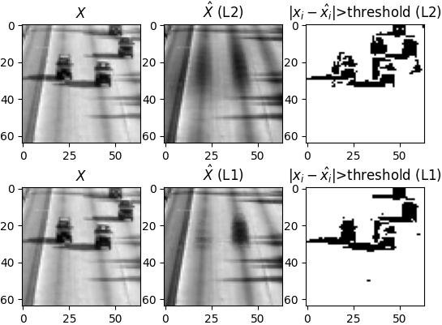
  - Reflection
    - The L1 loss is robust to outliers (cars), so the principal components focus purely on the consistent background (highway), ignoring transient objects. This produces cleaner background reconstructions and better foreground detection.
    - n = # frames, d = pixels per frame, k = # principal components
    - Increasing the threshold:
False positives:
Decrease - fewer background pixels exceed the higher threshold
False negatives:
Increase - parts of cars with small reconstruction errors fall below the threshold and are missed

Decreasing the threshold:
False positives:
Increase - more background noise exceeds the lower threshold
False negatives:
Decrease - more car pixels are correctly detected

- Movie Recommendations
  - Understanding Y
    - The matrix is initialized with np.nan values, and only the observed ratings are filled in.
    - $Y_train: 100,836 × 0.8 = 80,669 ratings$
$$Y_valid: 100,836 × 0.2 = 20,167 ratings$$
    - No, the same user-movie rating never appears in both Y_train and Y_valid. This is the expected result

  - Implementing Collaborative Filtering

W LOSS
def evaluate(self, w, Z, Y):
n, d = Y.shape
_, k = Z.shape
W = w.reshape(k, d)
# Compute residuals
R = Z @ W - Y
# Set NaN residuals to 0
R_masked = np.copy(R)
R_masked[np.isnan(R_masked)] = 0
# Compute loss
f = 0.5 * np.sum(R_masked ** 2) + (self.lammyW / 2) * np.sum(W ** 2)
# Compute gradient
g = Z.T @ R_masked + self.lammyW * W
return f, g.flatten()

Z LOSS
def evaluate(self, z, W, Y):
n, d = Y.shape
k, _ = W.shape
Z = z.reshape(n, k)
# Compute residuals
R = Z @ W - Y
# Set NaN residuals to 0
R_masked = np.copy(R)
R_masked[np.isnan(R_masked)] = 0
# Compute loss
f = 0.5 * np.sum(R_masked ** 2) + (self.lammyZ / 2) * np.sum(Z ** 2)
# Compute gradient
g = R_masked @ W.T + self.lammyZ * Z
return f, g.flatten()

  - Hyperparameter Tuning
    - $Train RMSE: 0.69$
$$Valid RMSE: 0.92 \\ k = 10$$
$$λW = 10$$
$$λZ = 10$$
  - Regularization with PCA
    - Without regularizing both parameters, the model finds a loophole by growing the unregularized parameter, leading to overfitting and poor generalization.
- Neural Networks
  - Neural Networks by Hand
    - $z^{i}=\left[\begin{matrix}0 \\ 0\end{matrix}\right]$
$$h\left(z^{i}\right)= \left[\begin{matrix}.5 \\ .5\end{matrix}\right]$$
$${\hat{y}}_{i}=3$$
  - Neural Networks Vs Linear Classifier
    - Training error: 2.79%
Validation error: 4.56%

hidden_feature_dims = [128]
output_dim = 128
learning_rate = 1e-3
batch_size = 500
max_evals = 20
lammy = 0.01
standardize_cols(X_train)
  - Neural Disentangling
    - Since z represents the output following the application of the sigmoid activation function, the axes are limited to [0, 1].
    - If the data is already linearly separable, using neural networks usually makes no sense.
    - Complex, non-linear decision boundaries can be learned more easily with higher-dimensional hidden features.
    - The network can learn hierarchical, compositional representations with more layers; basic features combine to form more complex features.
    - Random restarts with multiple initializations
- Very Short Answer Questions
  - Sparse solutions are easier to understand and allow us to pinpoint the precise latent factors that are important for each item or user.
  - New users benefit more from content-based filtering. Collaborative filtering has a "cold start problem" with new users who have no ratings because it needs user rating history to calculate user features (Z). Based on movie attributes (genre, actors, director) and any preference signals from the new user, content-based filtering can generate recommendations instantly.

  - Although they can be applied to unsupervised tasks, neural networks are primarily used for supervised learning. They are parametric models, meaning that regardless of the size of the training set, a set number of parameters are learned from the data.
  - Deeper networks have a lot more parameters, which significantly increases the model's capacity and overfitting risk. In order to keep the network from memorizing training data and to promote the learning of generalizable features, regularization becomes essential. Deeper networks can also fit more complicated functions, which facilitates overfitting to noise.
  - Total parameters = 2,605
  - When the derivative of the sigmoid function gets close to zero, it becomes flat for large positive or negative inputs. Gradients are repeatedly multiplied by these tiny derivatives during backpropagation through numerous layers, which causes them to exponentially shrink. Because early layers receive virtually no gradient signal and learn very slowly or not at all, this makes training deep networks very challenging.

  - Fully connected networks are impractical for images because they have far too many parameters

